|  |  |
| --- | --- |
| EGC_Black | Student Name \_\_\_\_\_\_\_\_\_\_\_\_\_\_\_\_\_\_\_\_\_\_\_    **Eastern Goldfields College**  Mathematics Essential Unit 3 2017  Test 31 |
| **Working Time: 20 minutes** | **Marks: 18 marks** |

**Calculator Free (No notes or calculator allowed)**

**Question 1** **(2 marks – 1,1)**

Circle the correct answer in each of the following multiple-choice questions.

### The three sides of a right-angled triangle measure 40 m, 41 m and 9 m. The length of the hypotenuse is:

### (i) 9 m (ii) 40 m (ii) 41 m (iv) none of these

1. A map has a scale of 1 : 5000. 5cm on the map is equal to how far in real life?

### (i) 5000 cm (ii) 2500 cm (iii) 25 m (iv) 250 m

**Question 2 (3 marks)**

Match each shape to it’s net

****

### Question 3 (4 marks)

Complete the following table

|  |  |  |  |
| --- | --- | --- | --- |
| Front | View From \_\_\_\_\_\_\_\_\_\_\_\_ | View From \_\_\_\_\_\_\_\_\_\_\_\_ | View From \_\_\_\_\_\_\_\_\_\_\_\_ |
|  | Plan | Front Elevation | Side Elevation |

**Question 4 (3 marks)**

Miss Jones, Mr Elliot and Mr Cook have all constructed pillow forts as seen in the diagram below. They wish to run cable to all 3 forts so that they can connect their laptops.

How much total cable will be needed?



8m

‘

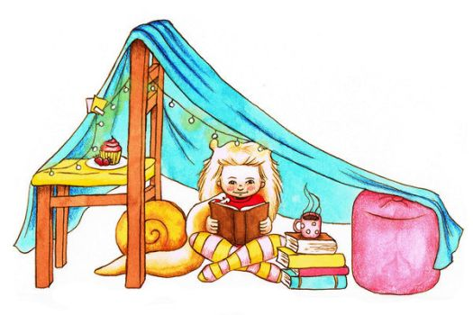

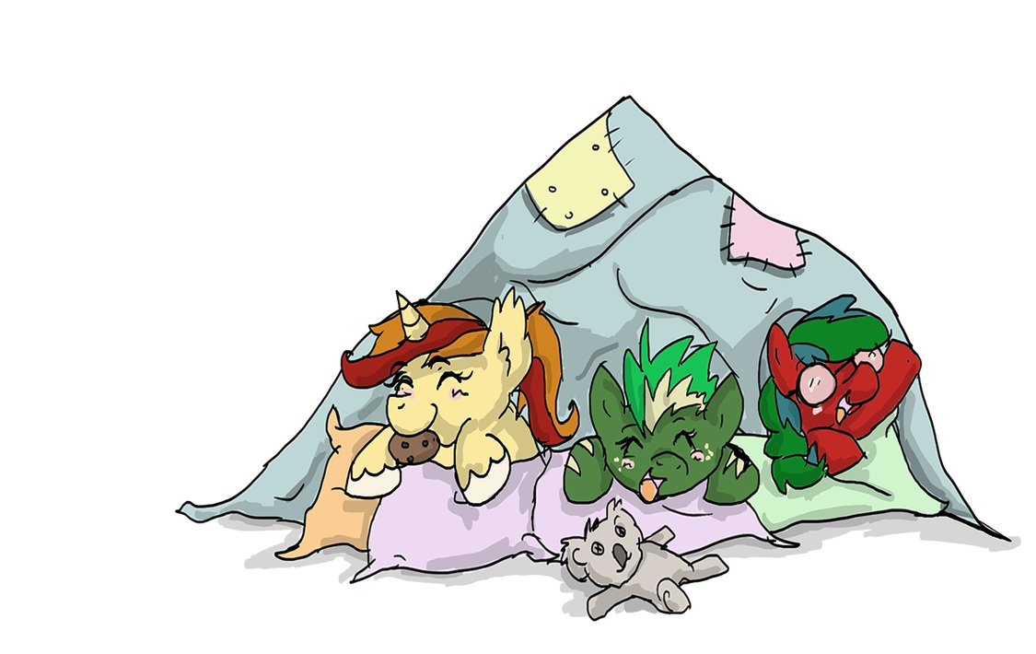

6m

### Question 5 (6 marks)

Create an accurate scale drawing of the diagram on the right to determine how far the boat is from each station.

20km

Use scale 1cm = 2km

|  |  |
| --- | --- |
| EGC_Black | Student Name \_\_\_\_\_\_\_\_\_\_\_\_\_\_\_\_\_\_\_\_\_\_\_    **Eastern Goldfields College**  Mathematics Essential Unit 3 2017  Test 31 |
| **Working Time: 35 minutes** | **Marks: 28 marks** |

**Calculator Assumed (Formulae sheet and one A4 page of notes)**

### Question 6 (6 marks: 2, 2, 2)

Draw and name the following shapes, according to the descriptions given below:

|  |  |  |
| --- | --- | --- |
| **Description** | **Name** | **Drawing** |
| (a) A 3D shape with 6 faces,   all of which are the   same size and shape. |  |  |
| (b) A 3D shape that is made   up of 5 faces – 2   triangles and 3  rectangles. |  |  |
| (c) A 3D shape which has a single curved edge, a   vertex and a circle base. |  |  |

**Question 7 (3 marks)**

|  |
| --- |
| A boy notices a bird sitting at the very top of a 10m tall tree. If he is standing 8m from the base of the tree, what is the distance between his eye and the top of the tree? |
|  |

**Question 8 (3 marks)**

The school council needs to have a ramp build over the steps of each of the building exits, to accommodate a student in a wheelchair. If the school building is 35cm off the ground and has steps that reach out 50cm, calculate the length of the ramp

**Question 9 (3 marks)**

Choose an appropriate method to display the characteristics of the following shape

**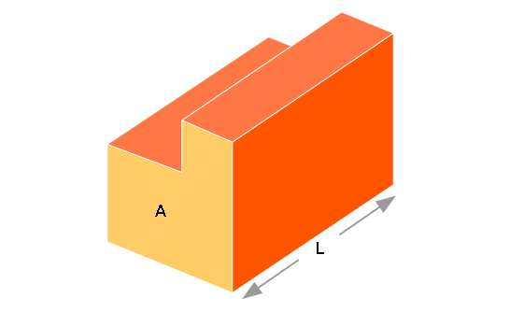**

**Question 10 (6 marks: 2, 2, 2)**

|  |  |
| --- | --- |
|  | Below is the floor plan for Mrs Wood’s new holiday house. |
|  | Scale 1: 200 |
|  | Using the scale given, find the area of the garage |
|  | Mrs Wood decides that she wants to concrete the floor of the garage. If concrete costs $21.20 per square metre, how much will it cost to complete? |
|  | The bathroom, laundry and ensuite are to be tiled, with tiles costing $41.40/m2. How much will it cost to buy tiles? |

**Question 11** (**7 marks)**

A basketball coach draws a line across the court that is exactly 7m away from the hoop (as seen in the diagram below). He gets 3 players to stand on the line for a shooting drill; one is directly in front of the hoop with the other 2 players set up either side. One of the players protests and says that this setup is not fair. Is the player correct? Justify with calculations

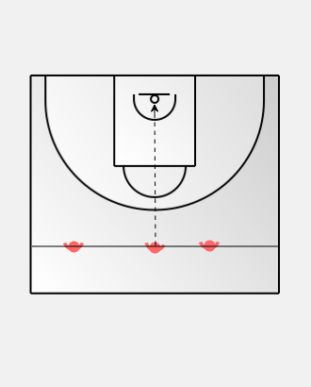

15m

4.5mm

5.5m

END OF TEST